

**SOFTWARE ENGINEERING LAB PROJECT**

**OBJECT DETECTION WEB APP**

**PROJECT REPORT**

**Submitted by**

**Muhammad Abu Ul Hassan**

**(202101004)**

**Danish Ali**

**(202101032)**

**Muhammad Nasarullah**

**(202101014)**

**BACHELOR OF SCIENCE**

**IN**

**COMPUTER ENGINEERING**

**Project Supervisor**

Engr. Zia ur Rehman

Lab Engineer

(Computer Engineering)

**DR. A. Q. KHAN INSTITUTE OF COMPUTER SCIENCES**

**AND INFORMATION TECHNOLOGY KAHUTA,**

**AFFILIATED WITH IST ISLAMABAD**

**STREAMLIT DASHBOARD REPORT OF PROJECT**

# DASHBOARD OVERVIEW

Dashboard Version: 2

## BACKGROUND INFO

The dashboard 2.0 is available for the following EPM solutions:

* Planning
* Financial Consolidation and Close
* Tax Reporting

Dashboard (1.0) and Dashboard 2.0 are using different backend technologies.

* Dashboard—Existing dashboards using Oracle ADF technology
* Dashboard 2.0—New dashboards using Oracle JET technology Dashboard 2.0 has a new icon.

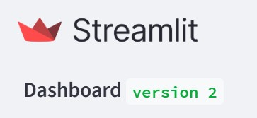

**Library** allows us to choose existing ad hoc and standard forms, chart types, and other objects

**Visualizations** allow us to add a different kind of charts. The supported chart types are Area, Bar, Bubble, Column, Combination, Doughnut, Funnel, Gauge, Geomap, Line, Pie, Pyramid, Radar, Scatter, Table with Spark Charts, Tile, Waterfall.

The dashboard is designed to display various visualizations related to weather and stock data. It utilizes the Streamlit library for creating interactive web applications with Python.

## INTRODUCTION

This report details the development of an Object Detection App utilizing the YOLOv4 model. The app allows users to upload images and detects and classifies objects within those images in real-time. The YOLOv4 model is employed for its efficiency and accuracy in object detection tasks.

This project revolves around the development of an advanced Image Detection Web App, leveraging the power of the YOLOv4 model. The app is designed to empower users to upload images and receive real-time detection and classification results, making it a valuable tool for various applications such as security, content moderation, and beyond.

As the demand for robust image detection solutions continues to grow, our project aims to provide a seamless and efficient experience for users seeking to identify objects within images. The YOLOv4 model, known for its efficiency and accuracy, serves as the backbone for our app's object detection capabilities.

**Project Purpose**

The primary purpose of our Image Detection Web App is to offer a comprehensive and efficient solution for detecting multiple classes within an image. This project addresses the growing demand for advanced image recognition systems capable of accurately identifying and classifying diverse objects in real-time. The key purposes of the project are:

**1. Multi-Class Object Detection:**

- The project focuses on utilizing the advanced capabilities of the YOLOv4 model to detect and classify multiple classes of objects within a single image. This is particularly valuable in scenarios where diverse objects coexist, such as in security surveillance, content moderation, and visual analytics.

**2. Real-Time Processing:**

- The app's design emphasizes real-time processing, allowing users to receive instant feedback on detected objects. This feature is crucial in applications where timely information is essential, such as in security monitoring or interactive environments.

**3. User-Friendly Interface:**

- We aim to provide a user-friendly interface through the Streamlit framework, making the complex task of multi-class object detection accessible to users with varying levels of technical expertise. The intuitive design ensures that users can effortlessly upload images, trigger detection, and interpret the results.

**4. Detailed Classification Information:**

- Our project goes beyond basic object detection by providing detailed information about the recognized classes. Users can understand not only what objects are present in an image but also receive insights into the accuracy levels associated with each identified class.

**5. Versatility and Applications:**

- The versatility of the project allows it to find applications in various domains. Whether used for security purposes to identify potential threats, content moderation to filter inappropriate content, or in research to analyze visual data, the project serves as a valuable tool.

**6. Continuous Improvement:**

- The project lays the groundwork for continuous improvement. By envisioning future enhancements such as multi-image processing and customizable confidence thresholds, we aim to adapt and evolve the app to meet the dynamic needs of users and emerging technologies.

**Technical Overview**

**YOLOv4 Integration**

The YOLOv4 model is integrated into the app using pre-trained weights and configuration files. The model is loaded using OpenCV's dnn module, enabling seamless object detection.

**User Interface**

The app is designed using the Streamlit framework, providing an interactive and user-friendly dashboard. Users can upload images, trigger object detection, and view the results on the app interface.

**Dashboard:**

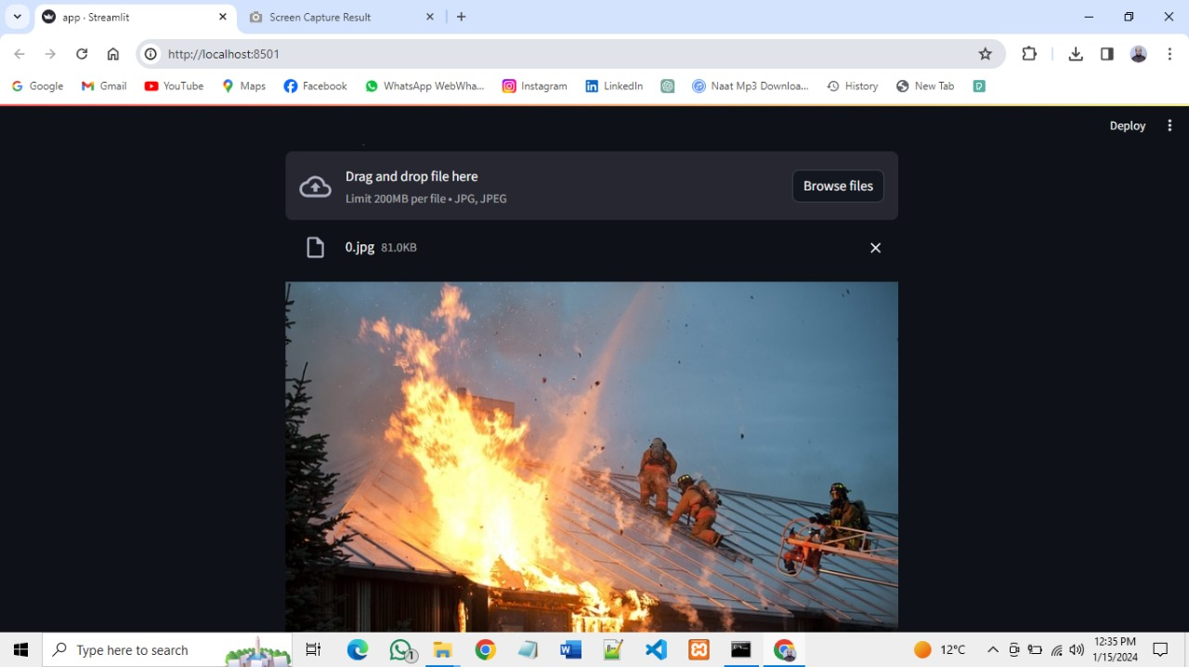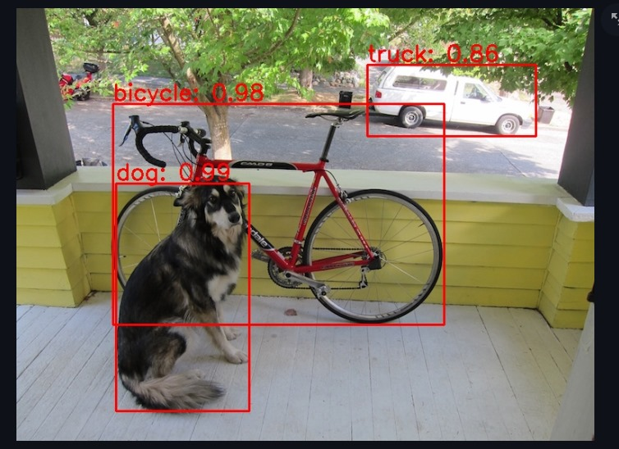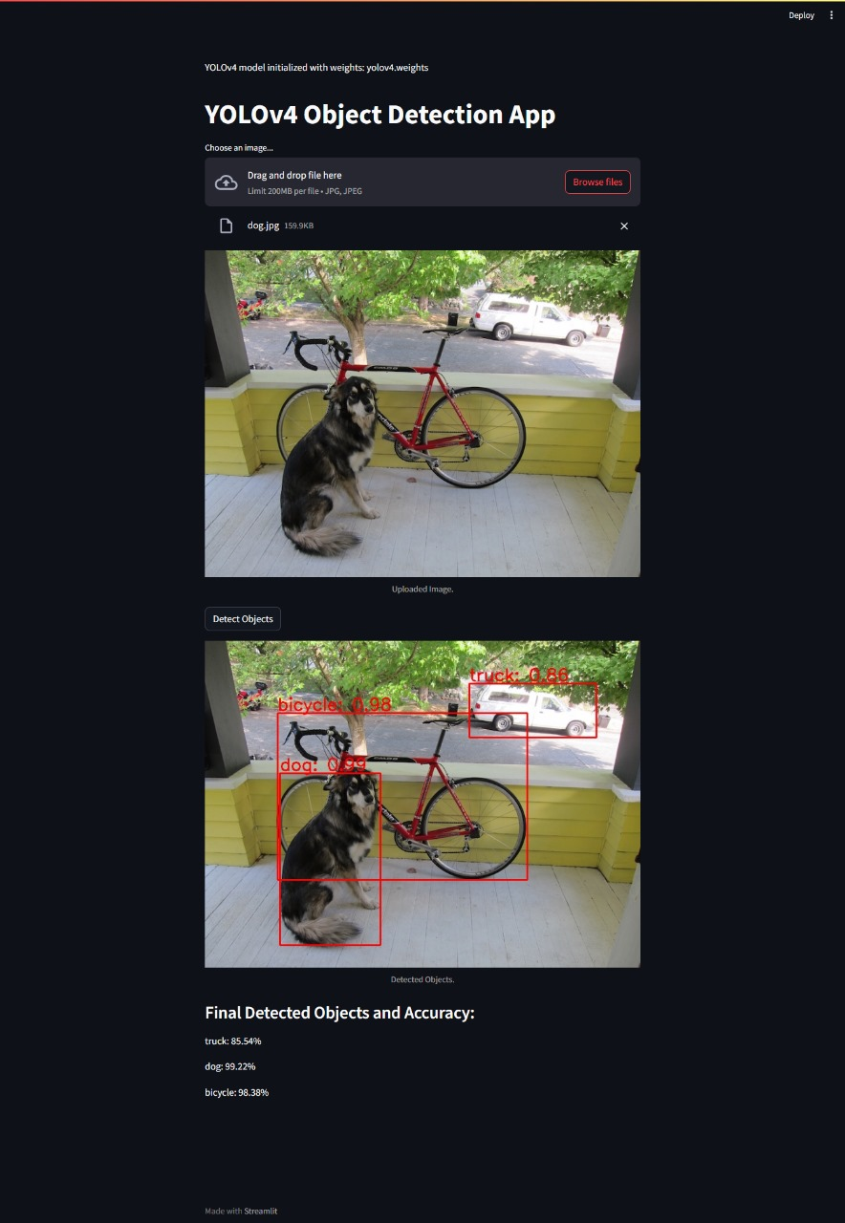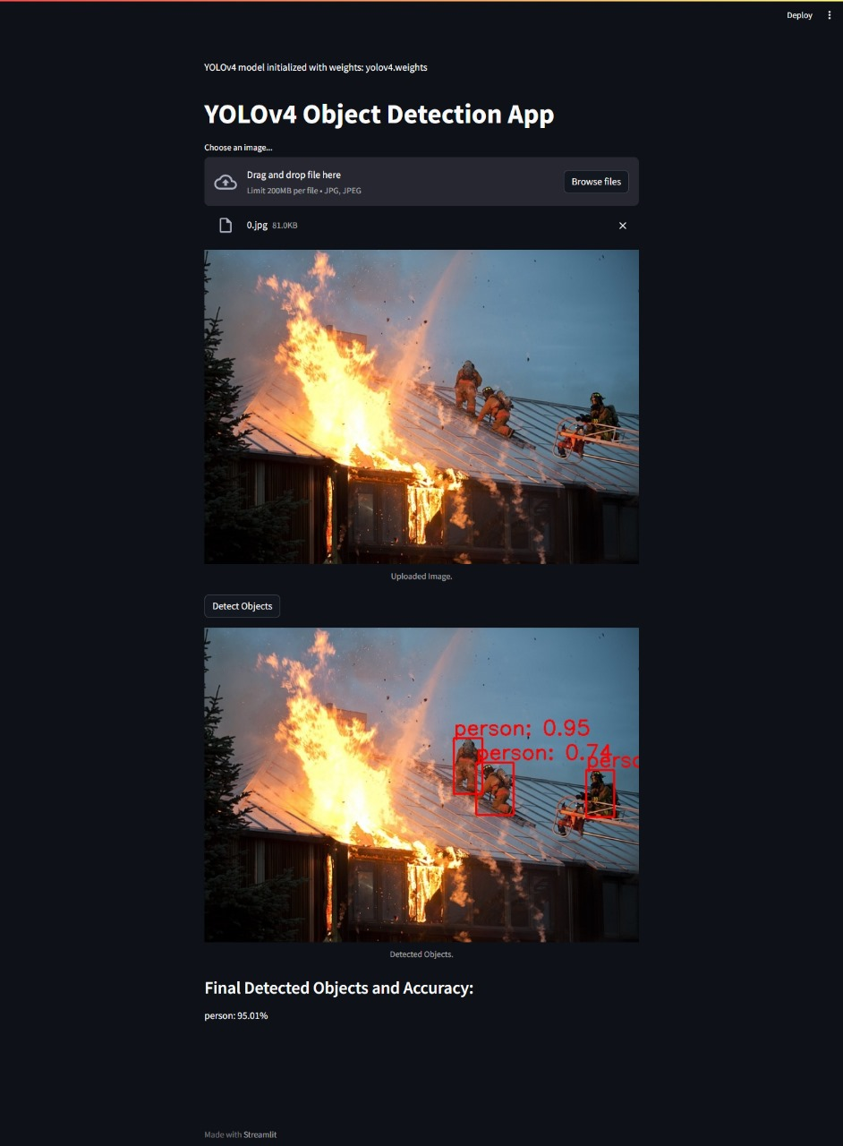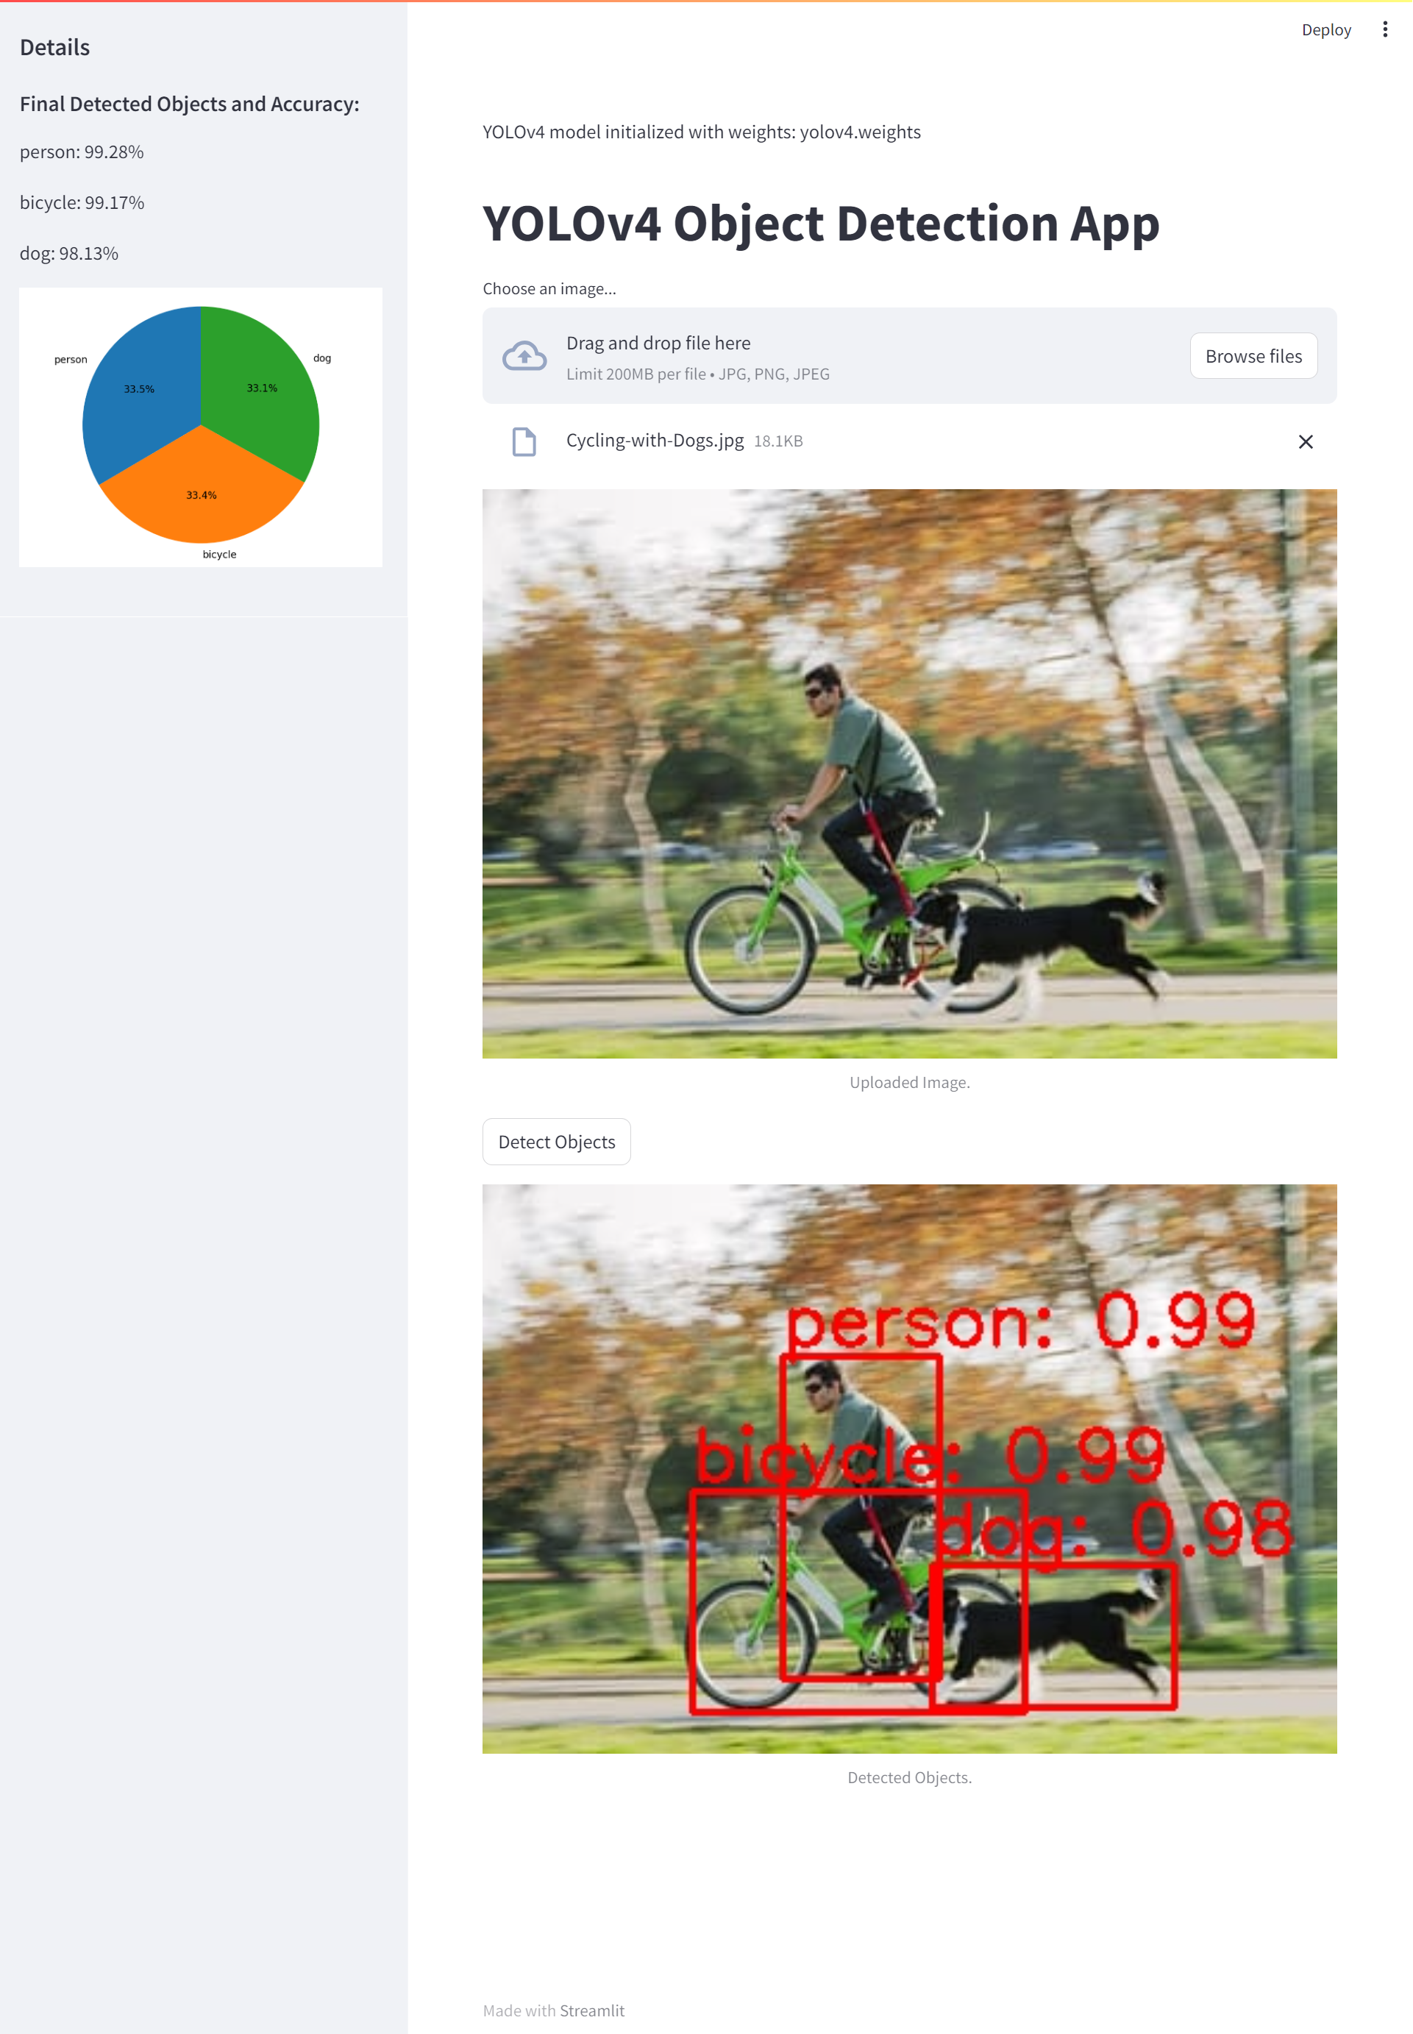

**Our systems detects classes :**

|  |  |  |  |  |  |  |  |  |  |
| --- | --- | --- | --- | --- | --- | --- | --- | --- | --- |
| person | bicycle | traffic light | zebra | snowboard | bottle | sandwich | chair | mouse | refrigerator |
| bicycle | car | fire hydrant | giraffe | sports ball | wine glass | orange | sofa | remote | book |
| car | motorbike | stop sign | backpack | kite | cup | broccoli | pottedplant | keyboard | clock |
| motorbike | aeroplane | parking meter | umbrella | baseball bat | fork | carrot | bed | cell phone | vase |
| aeroplane | bus | bench | handbag | baseball glove | knife | hot dog | diningtable | microwave | scissors |
| bus | train | bird | tie | skateboard | spoon | pizza | toilet | oven | teddy bear |
| train | truck | cat | suitcase | surfboard | bowl | donut | tvmonitor | toaster | hair drier |
| truck | boat | dog | frisbee | tennis racket | banana | cake | laptop | sink | toothbrush |

**App Functionality**

**1. Image Upload**

Users can upload images through the app interface. The system supports various image formats, providing flexibility to the users.

**2. Object Detection**

Upon image upload, the YOLOv4 model processes the image and highlights detected objects with bounding boxes. Each object is classified, and the confidence level is displayed.

**3. Classification Details**

The app not only detects objects but also provides detailed information about the recognized classes. Users can understand the content of the image with the associated labels.

**4. Final Detected Objects and Accuracy**

After the detection process, the app displays the final detected objects along with their accuracy percentages. This provides users with insights into the reliability of the detection results.

**Key Features**

1. Real-time Processing: The YOLOv4 model enables real-time object detection, offering instant feedback to users.

**2. User Interaction:**

The Streamlit framework ensures a smooth user experience, allowing easy navigation and interaction with the app.

**3. Accuracy Details:**

Users can not only see the detected objects but also understand the accuracy level for each identified class.

Future Enhancements

**1. Multi-Image Processing**

Extend the app to handle multiple images in a batch for efficient processing.

2. Customizable Confidence Threshold:

Allow users to adjust the confidence threshold for object detection based on their requirements.

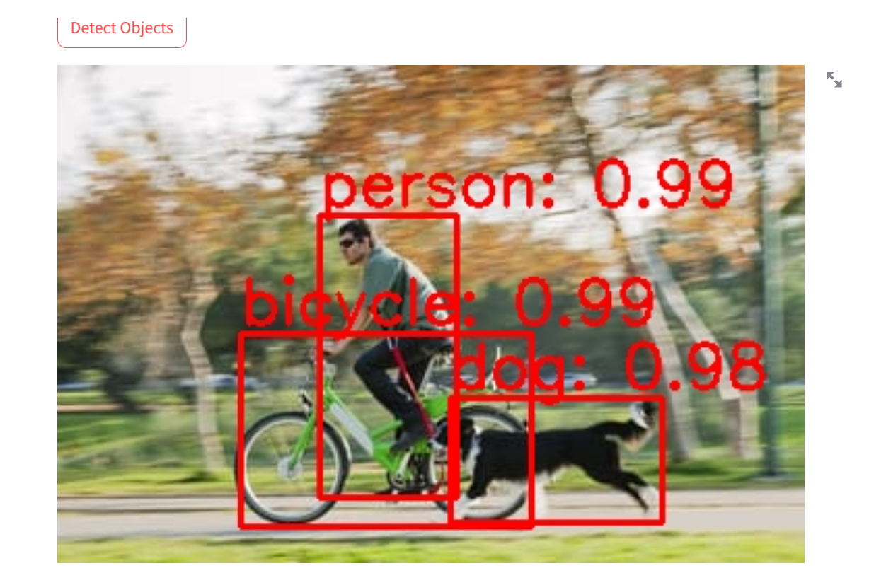

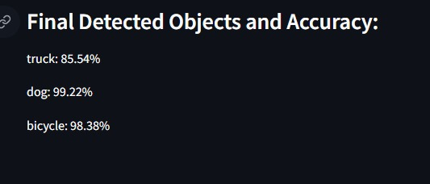

**Conclusion**

The Object Detection App utilizing YOLOv4 provides a powerful solution for users interested in identifying objects within images. The seamless integration of the YOLOv4 model with Streamlit ensures a user-friendly and efficient experience. This app can find applications in various domains, including security, content moderation, and more.

our Image Detection Web App represents a significant step forward in providing users with a powerful, accessible, and accurate tool for object detection. By combining the capabilities of YOLOv4 with the user-friendly interface of Streamlit, we aim to make image detection an intuitive and efficient process for a wide range of applications.

Link of github:

https://github.com/MuhammadNasarullah575/SE-Lab-Project